Snow day package!!
This is a “just in case” care package for if we ever have a storm day and you are looking for ideas of things to do at home (in between shoveling and playing in the snow!!!) I encourage you to go to our “links” page on our weebly and play some online French games and listen to online French stories as well if possible! I also encourage you to go back to old homework pages and review our words and messages! This document will be uploaded onto our weebly and I will add to it as I find more activities.
www.mmerobyn.weebly.com

Qu’est-ce que tu penses Madame va faire aujourd’hui?
What are you think Madame is going to do today?

You can make a word search for your child using our weekly words!
Les mots:
___________ ___________
___________ ___________
___________ ___________
___________ ___________
Have some fun with toilet paper rolls!
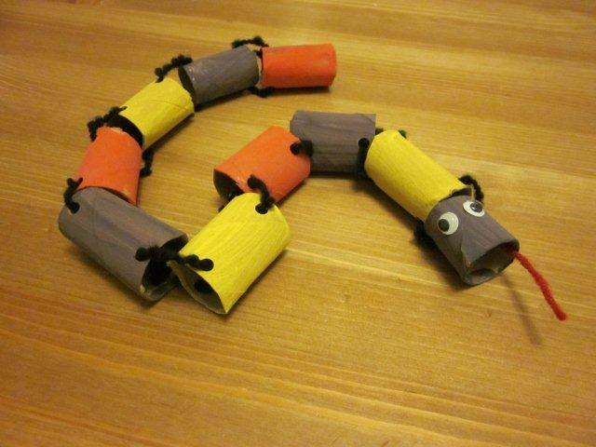
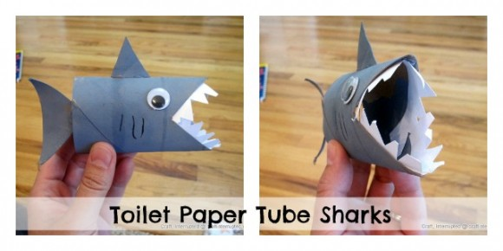
Play a “build a snowman” math game!
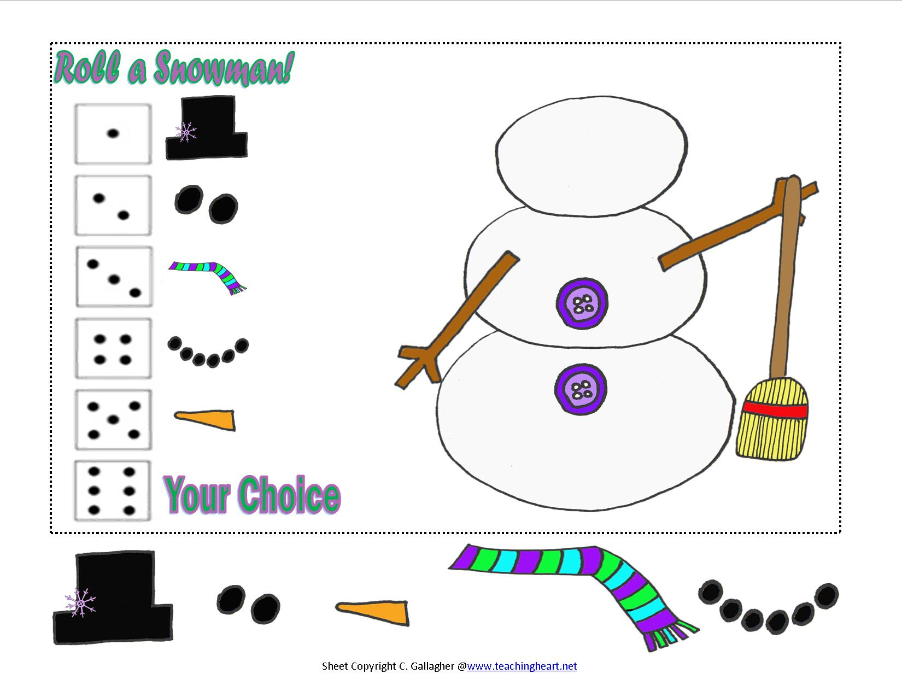

Have your child create a puzzle – draw image, then cut out pieces and try to put it together!

Combien de mots peux-tu écrire en utilisant les lettres dans
How many words can you make using the letters in this saying:
Aujourd’hui il y a une tempête de neige! Il n’y a pas d’école! Qu’est-ce que tu vas faire?
non
oui

Make a snow globe! It is fun to cut out and put a light layer of glue and glitter on it to look like snow falling inside. Have your child write a story about what is happening in the snow globe…or what it would be like if they lived in a snow globe!!!

